* This is what Teshome from Tegbareid is doing:  
    
  Currently there are several equipment like ECG monitors and ventilators in the country that are not working. Teshome from Tegbar Ed Polytechnic is helping with repairing them to assist with the fight against the virus. His efforts have been recognized by the Ministry of Health - Dr Lia Tadesse.   
    
  Teshome joined the ECRT’s project to help manufacture ventilators in Ethiopia. He has shared with the team the parts that he needs to repair the remaining items.

<https://m.facebook.com/story.php?story_fbid=1155515131470349&id=832403160448216?sfnsn=mo>

* This is what Teshome needs

<https://drive.google.com/open?id=1EtOMuQZdswA6eip0Jmq0ds1lmqq8hSzR>   
<https://drive.google.com/drive/u/0/folders/14Nbl30ZdlBuFUWSs9fcTJb0IInTF4IhU>

<https://docs.google.com/spreadsheets/d/1OKLIk86wIXym2wqHh6cRr_snB5tVM_Y9/edit#gid=2088322240>

* This is where we can get it

<https://docs.google.com/document/d/1Bdvlj3yXShjEV7o6SIaHAXwQqCDX0ahC/edit>

Links have been updated :

<https://docs.google.com/document/d/1MDeebTvcENiKIAYwdzhMTVtLVBWYW26m/edit>

* This is how much it costs.

<https://docs.google.com/spreadsheets/d/1KlWemwnPVk4OOu4BwTmTMRRhn--RoCSMuW_988v-LVY/edit#gid=2088322240>

Email to sellers :

Sent to

|  |
| --- |
| **Shenzhen Pray-Med Technology Co.,Ltd** |

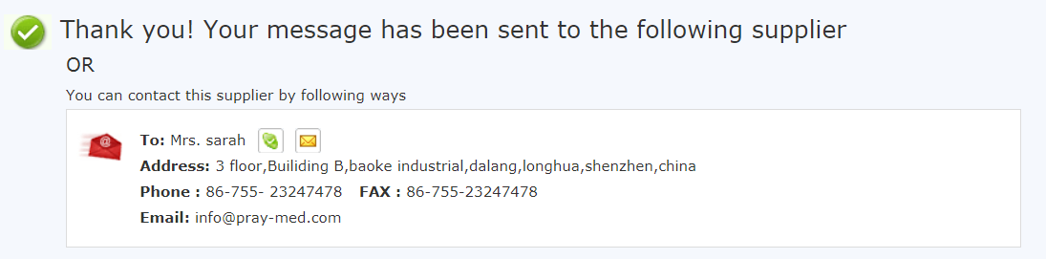

Oudaisi Wang Shenzhen Emslife Technology Co., Ltd

Hello,

I'm sending the following message to inquire about a list of accessories needed for medical equipment. I would like to order the items below to be shipped to Addis Abeba, Ethiopia as soon as possible. The request for these accessories is to maintain several equipment in preparation for COVID-19 related hospitalizations. As such, I would appreciate your prompt response to my request.

Please find below this list of items. Feel free to contact me for any additional details. Please let me know if these parts are available through your company and their respective costs. If you could also let me know about available shipping methods to Ethiopia, that would be great.

Thank you in advance,

Mateos

List of items :

|  |  |  |
| --- | --- | --- |
| no. | Equipment model/serial no. | Item |
| 1 | Anyview:A8/A6/A5/A3 S/n:A027E001158 | BP Cuff with extension cable |
| EMS-module |
| Spo2 probe with extension cable |
| CH-25-25-01 s/n:302303 | BP Cuff with extension cable |
| Spo2 probe with extension cable |
| Caredo F5 s/n:caredoF5 (Yvzs034) | adult BP Cuff with extension cable |
| Spo2 probe with extension cable |
| Mindray | Spo2 probe with extension cable |
| Adult Bp cuff with extension cable |
| Boilight | Spo2 probe with extension cable |
| Adult Bp cuff with extension cable |
|  | Spo2 probe with extension cable |
|  | Philips | Adult Bp cuff with extension cable |
| 2 | Spo2 probe with extension cable |

I would like to know about the availability of accessories for two of your devices : Biolight AnyView Modular Patient Monitor: A8 and Biolight V6 Patient Monitor | Vital Signs Patient Monitor

The accessories I am looking for are SpO2 probe, Temperature probe, ECG lead, IBP probe, NIBP extension tube, and NIBP Cuff.